Q1. Count the number of lines, character of a file.

Q2. Suppress the write and execute permissions for group and others.



Q3. set the default file permission



Q4. Give the complete rights to the user i.e. read, write, execute for the group, read & write for others only.



Q5. Search all lines in a file which ends with a semicolon.

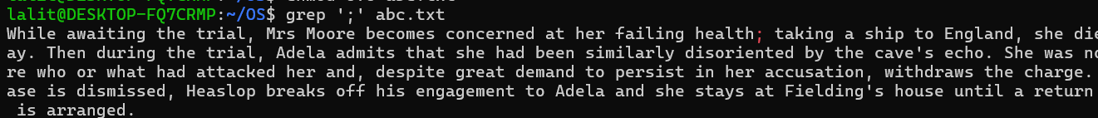

Q6. Search all lines in a file which do not end with semicolon



Q7. Create the emp. lst Database having following data. (Use VI editor to type the following. Use the default delimiter as Tab key.



Q8. Show the fields 2-5 from emp.lst.

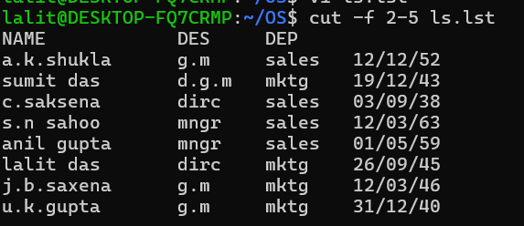

Q9. Show the fields 2-5 from emp.lst where delimiter is ‘.’

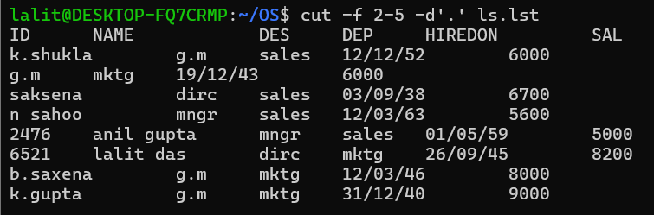

Q10.Display only the name field from emp.lst.

Q11. Display only the emno field from emp.lst

Q12. Display empno field & department name from.

Q13. Display 4 records from the beginning of emp.lst..

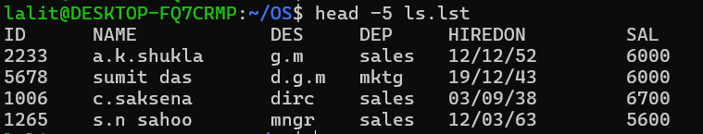

Q14.Display 30th char from the beginning of emp.lst.



Q15. Display 3 records from beginning of emp.lst converting to upper case.

Q16. Display last 3 records from emp.lst.

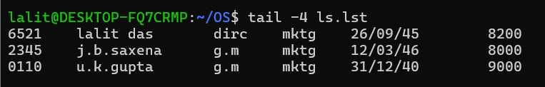

Q14. Create three separate files named as a ,b & c and add some contents.

Q18. Merge, sort & then display the files a,b,c on screen.

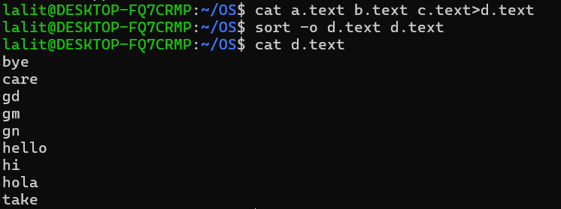

Q19. Display the records from emp.lst and save in templist.



Q20. Show the system memory available & its usage.

Q21. Show the amount of free space in each mounted file system.

